WEB PROGRAMMING (BIT210)

ASSIGNMENT 1 (PART 1)

TITLE OF PROJECT:

SENIOR CITIZEN HELP PROVIDER(SCHP)

TEAM MEMBERS:

Elebe Faith Alfred – B1301511

Lughano Vincent Ghambi - B1401675

**TABLE OF CONTENTS**

Manual Guide 3 - 13

Screenshot of Web Pages and Corresponded of Elements 4 - 20

Web Pages and Its Codes 14 - 20

Challenges Faced During Web Development 49

Web Development Framework and Technologies Used 50

References **5**0

**MANUAL GUIDE OF WEB SETTING/CONFIGURATION/INSTALLATION/FILE ORGANIZATION**

Senior Citizen Help Provider (SCHP) is an information system that can match service providers with seniors who require such services. These seniors would be able to find information about services that are available and submit a request for a particular service. The available service providers can then accept the service requests.

This site provides the following functionalities:

1. An SCHP user will be required to sign up to be able to access the privileges offered by the website. The user can be a Senior or a Service Provider. The privileges offered to a user includes requesting for a service, accepting a service request, managing a service request and reviewing system users. The system validates user inputs such as name, password, mobile number and address.
2. The system will permit the Senior to select request for service. The system will display service types available through service code and description. The system will permit the Senior to enter required service code, date and notes. The service request is created for the Senior, the requestID is automatically generated, the status is set to “pending”. The ServiceRequest is recorded for the ServiceType. If the serviceCode or required Date is invalid, the system returns an error message.
3. There is a functionality on the website that will allow the Service Provider to view pending request, view details of a request such as required date, notes and status by selecting “view details” and also accept a request from a Senior. The Service Provider will also be to update notes on the website. The system will return an error message if the requestID is not found or the status of the request is not pending.
4. The system will permit the Service Provider and Senior to manage service request on the website when the SCHP user selects manage request. The system will display list of service request in which the user can select from. Service request management include the enablement of the user to change the status of a service and update notes.
5. The system will display the name of a Senior and the Service Provider thereby permiting an SCHP user to review users of the system when a user selects the requestID of a service request.
6. The system will also allow a user to view the ratings for services rendered on the website and users will also be able to review other users.
7. Compliance to W3C standards for accessibility and disability.
8. The interface displayed by the system will be simple and convenient for the user to understand and use. This means that the website font will be easy for the user to see and read. The navigations will be placed where the user can see it easily to click on.

First, the website can only be accessed using Desktop, Laptop, Notebook, or Tablet computer. It can also be accessed using a smart phone.

Users must be connected to the internet.

Devices mentioned above must have any of these web browsers: Google Chrome, Internet Explorer, Firefox, Microsoft Edge, Opera, UC Browser and Safari.

This manual explains the ways in which this site can be used to get the most out of it. For all further questions, please get in touch with System Managers. Contact details can be found at the foot of each page.

**STEP ONE: (For all Users):**

**Home Page:**

User can go to the Home Page to read about the purpose of the site.

On the Home Page too User can gain access to the site’s functionalities by clicking on the “Log In” button.

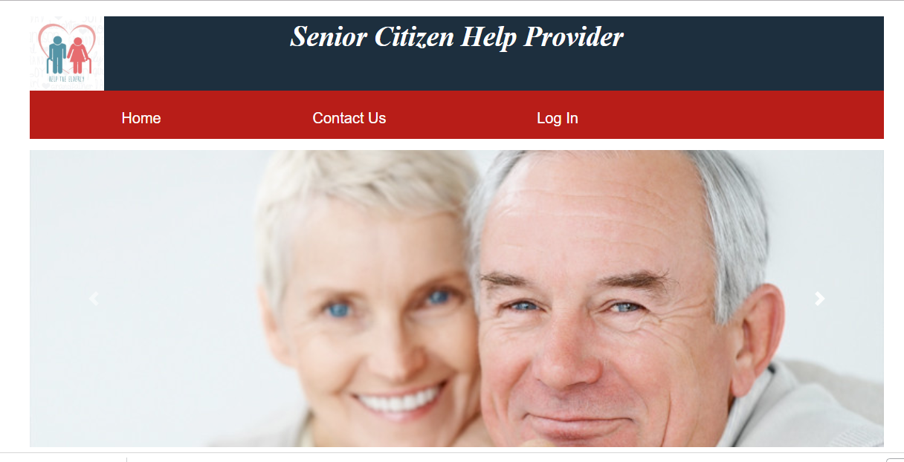

**STEP TWO: (For all Users):**

**Login Page:**

Users who have signed up already are required to input every information required in the boxes provided. Then click on the “Login” button. Users who haven’t signed up can sign up by clicking on the “Sign up” link provided.

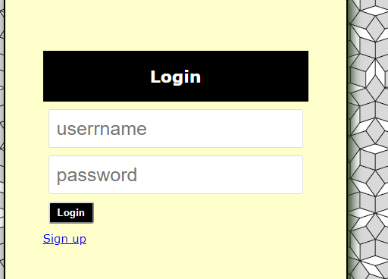

**STEP THREE: (For all Users):**

**Sign up Page:**

Users who are Service Providers are required to select the “Service Provider radio button”, and after that select the service code from the dropdown button beneath it and input every necessary information required in the boxes provided and click on the “create” button. Users who are Seniors are required to select the “Senior radio button”, and after that input every necessary information required in the boxes provided except the box that requires “Service code”. And click on the “create” button.

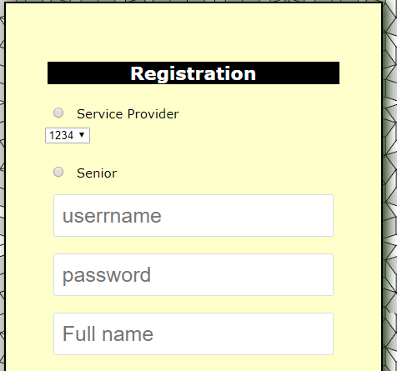

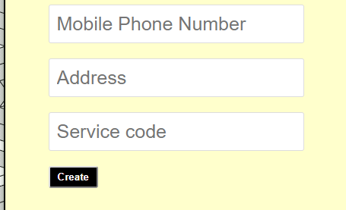

**STEP FOUR (SENIOR):**

**Request Service:** For a Senior to be able to request a service, click on the “Request Service” navigation button.



**STEP FIVE(SENIOR):**

**Request Service Page:**

Once you are on the “Request Service” page, click to choose a “Service Request Code”. You can read through the page to know what each code represents.



After choosing a service request code, click on the “Submit Service” navigation button.



**STEP SIX(SENIOR):**

**Submit Service Page:**

Enter Service Code, enter date required (the day you want the service to be delivered), enter notes describing the service you require. Click on the “submit” button to submit the request.

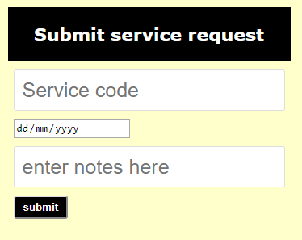

**STEP SEVEN(SENIOR):**

**Manage Service Page:**

It is not compulsory for a Senior to manage service. Click on the “Manage Service” navigation button.



Click on “View Details” button to view details about the service request.

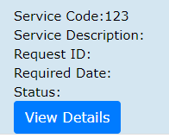

If interested, click on “Review User” to review user.

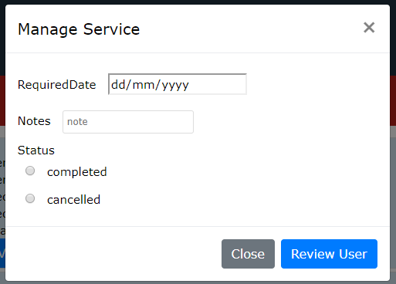

If interested Change Status



If interested Update Notes



**STEP THREE: (Service Provider):**

**Accept Request Page:**

Click on the “Accept Request” button to accept service request from Seniors.



Click on “View Details” button to view details about the service request.

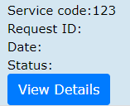

Click on the “Accept” button to accept the service request.

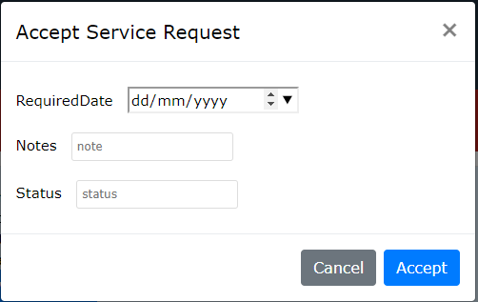

If Interested update Notes.



**STEP FOUR (Service Provider):**

**Manage Service Page:**

It is not compulsory for a Service Provider to manage service. Click on the “Manage Service” navigation button.



Click on “View Details” button to view details about the service request.

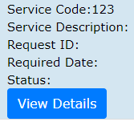

If interested, click on “Review User” to review user.

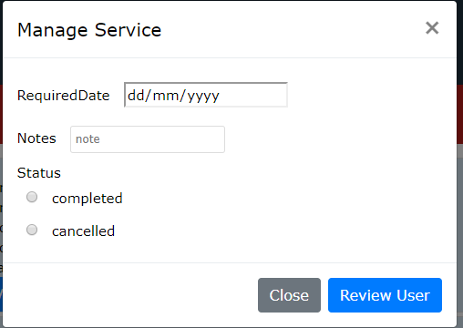

If interested Change Status



If interested Update Notes



**Review User Page (For All Users)**

It is not compulsory for a Service Provider or a Senior to review another user. But this page also helps the User to see the reviews of other Users. Click on the “Review User” navigation button.







Click on the name of the individual.

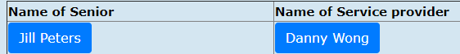

Scroll down to view rating, comments etc.

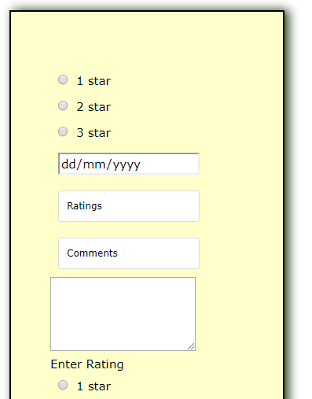

If interested, view Reviews.



**Contact Us Page (for all Users):**

Click on the “Contact Us” navigation” to enable you contact the system managers.



Input all the required information.

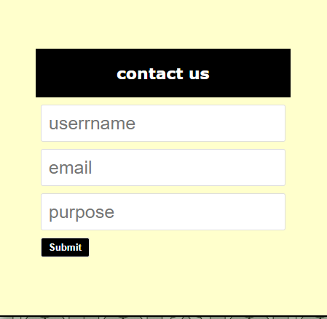

Click on the “Submit” button.



**WEB PAGES SCREENSHOTS**

**Home Page:**

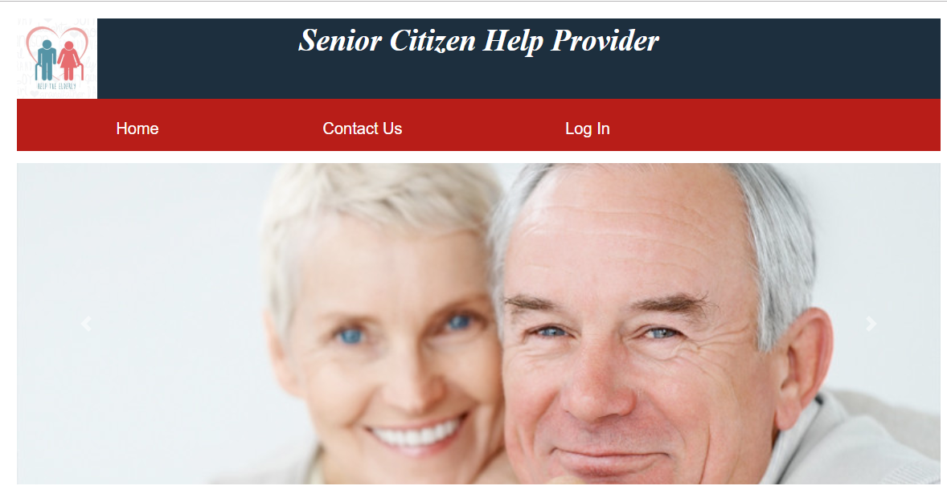

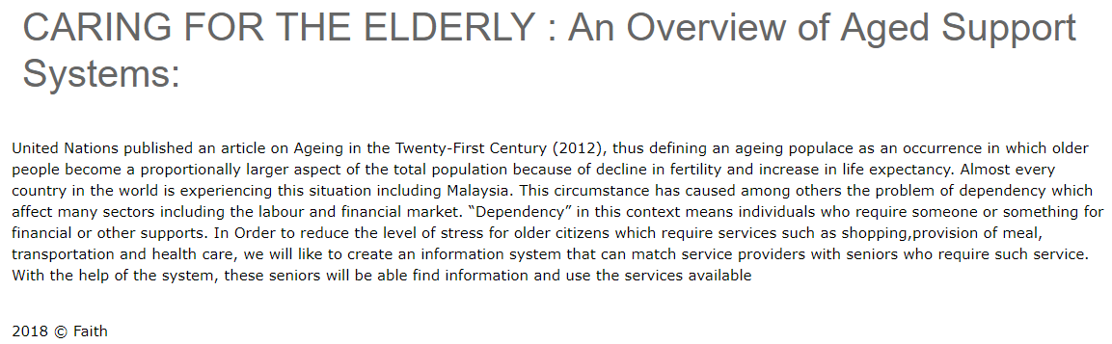

**Home2 Page:**

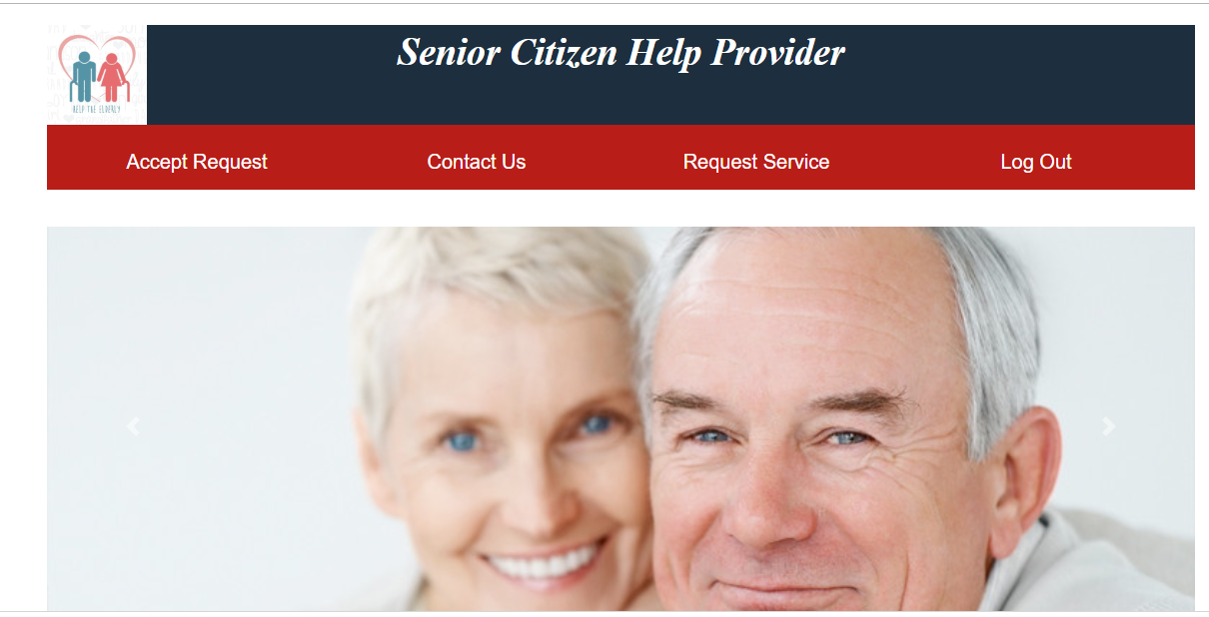



**Login in Page:**

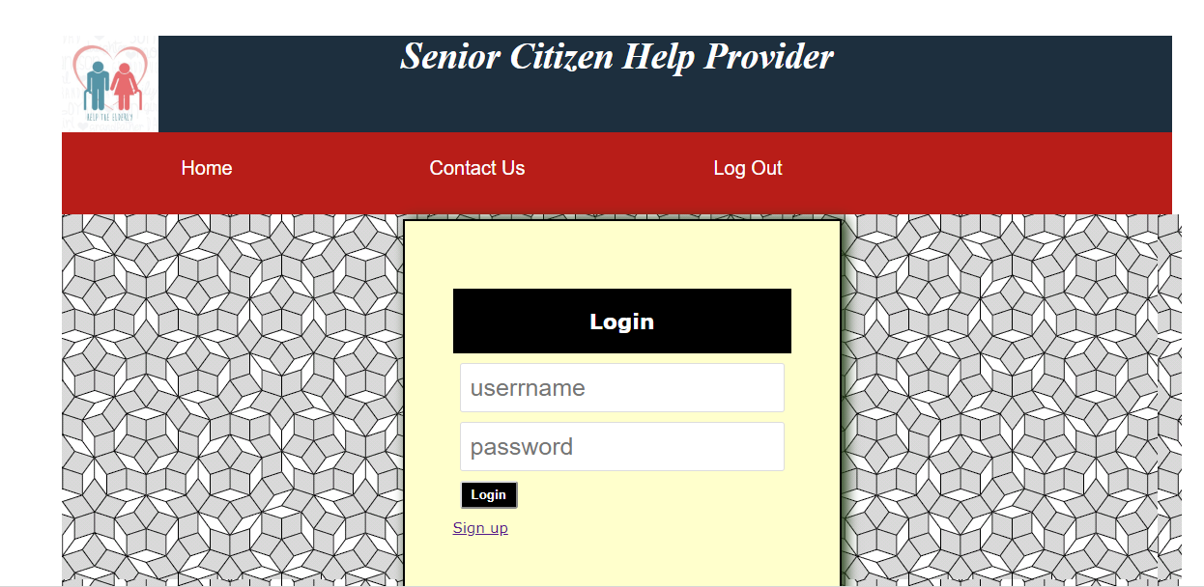



**Sign up Page:**

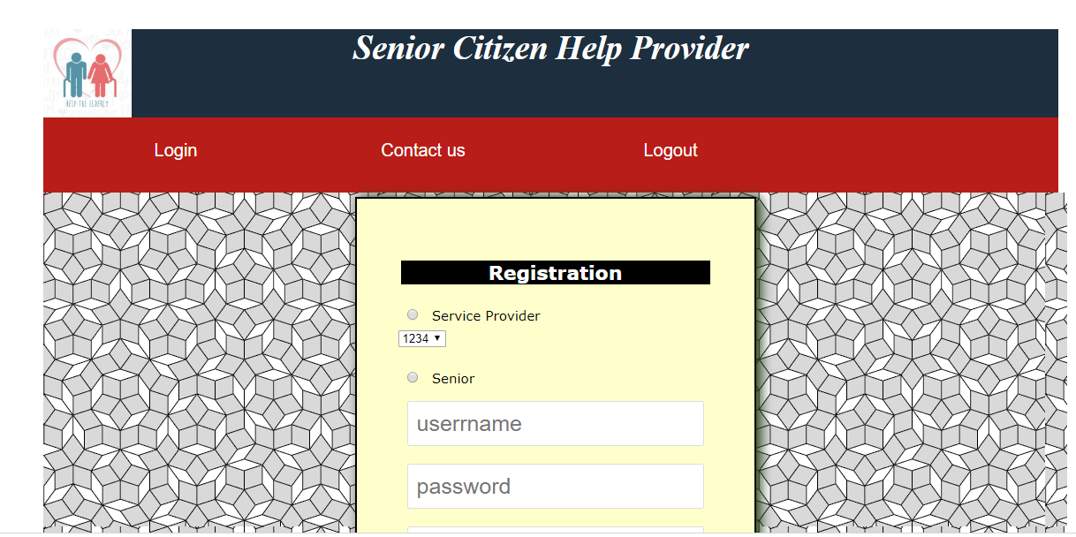

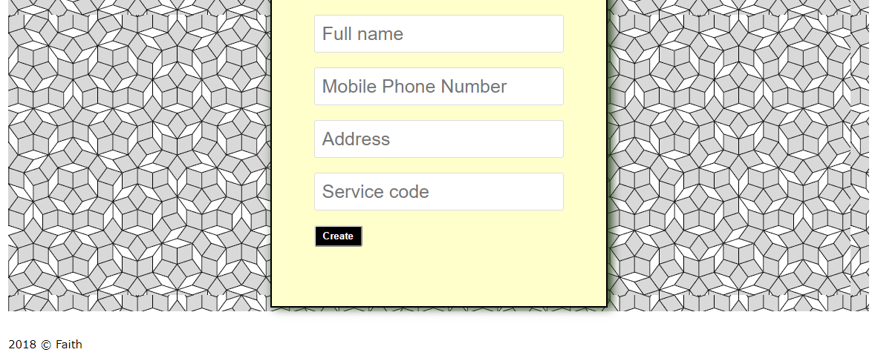

**Request Service Page:**

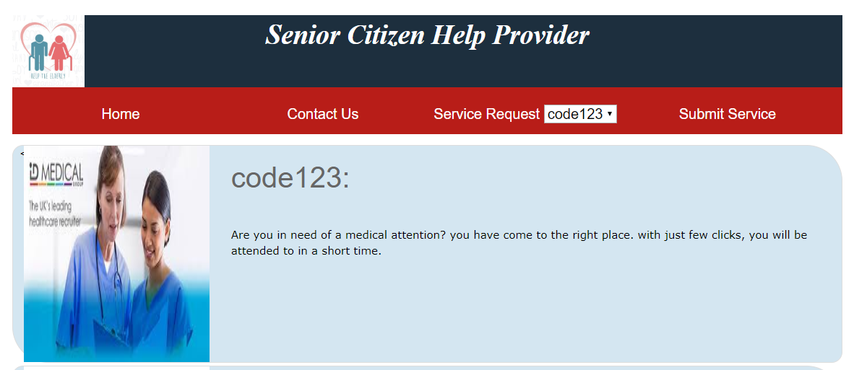

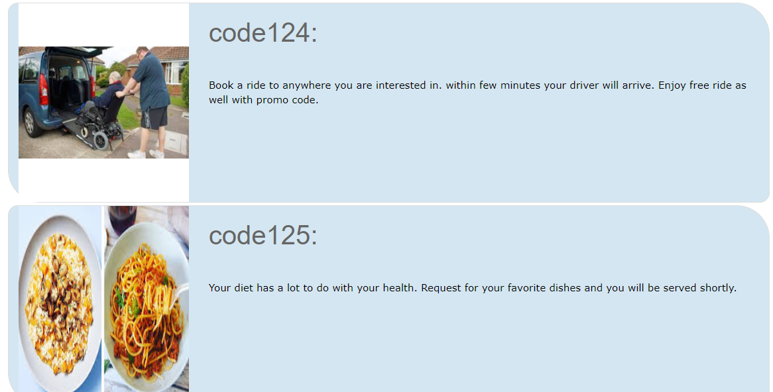

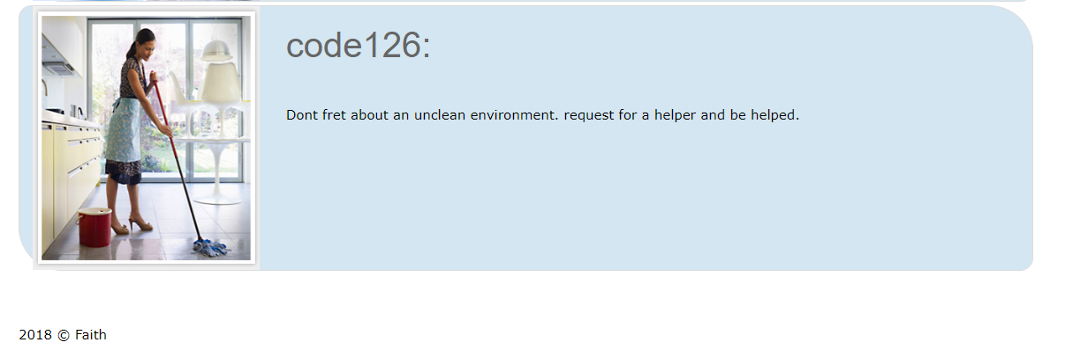

**Submit Service Request Page:**

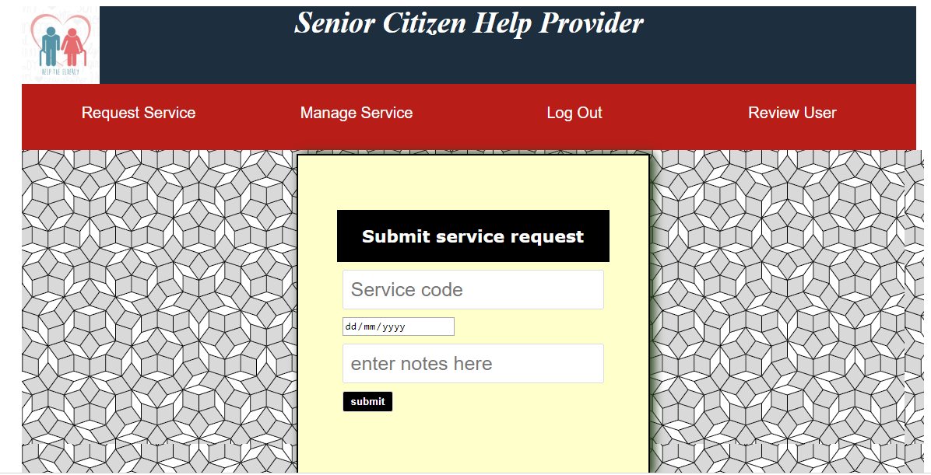

**Accept Service Request Page:**

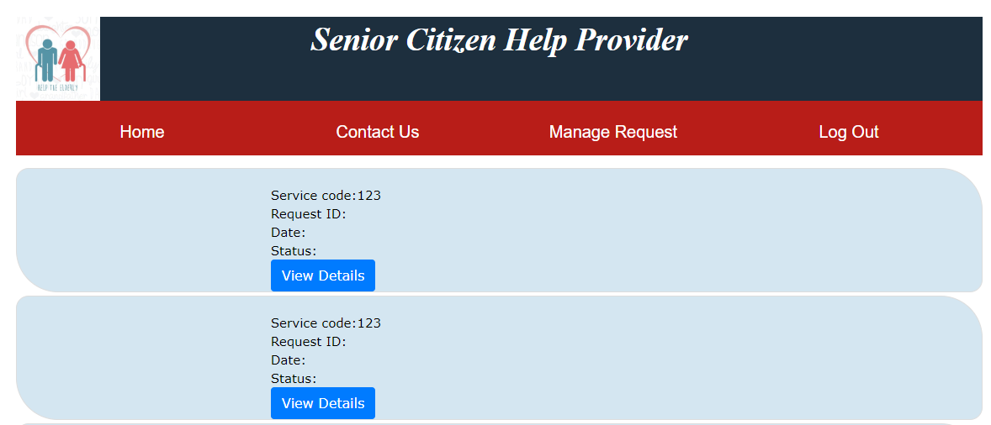

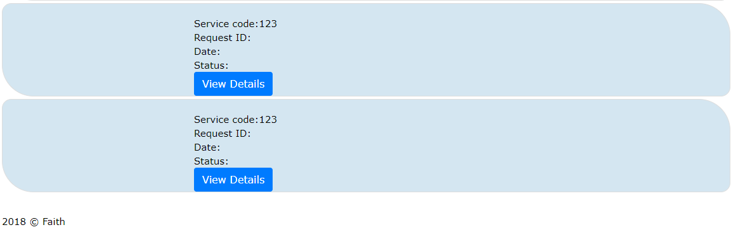

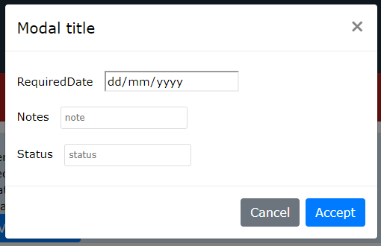

**Manage Service Request Page:**

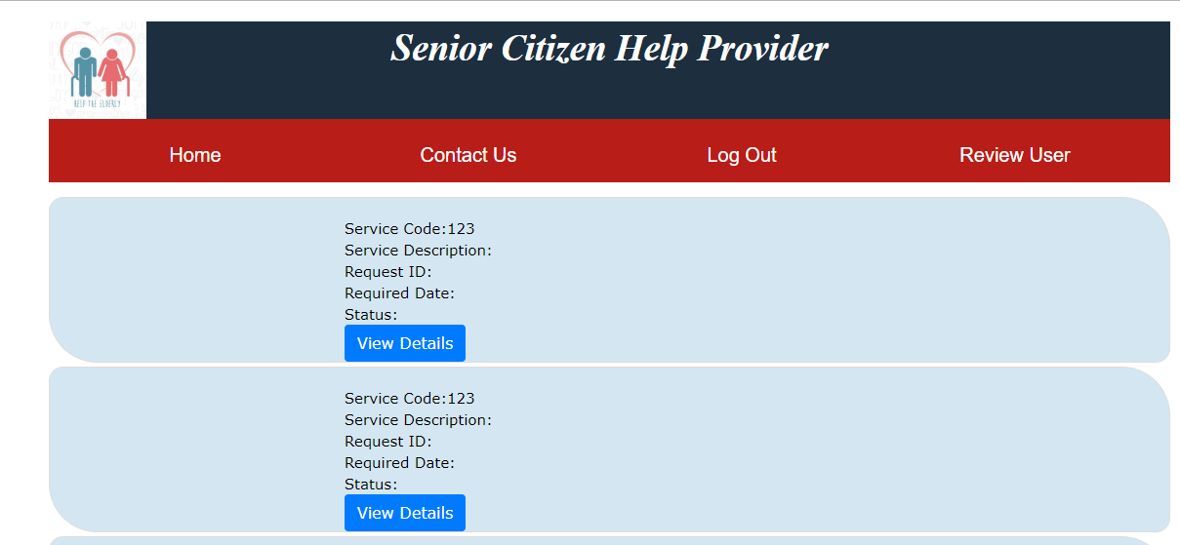

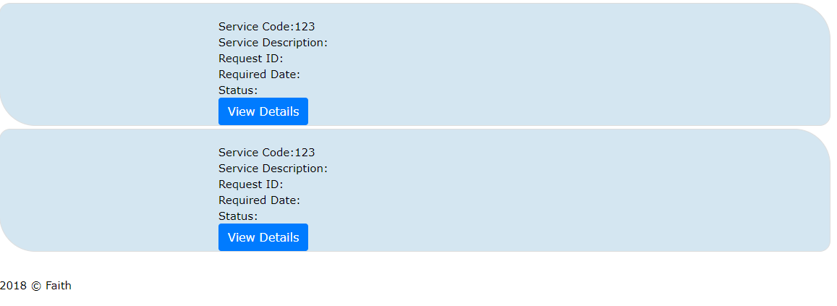



**Review User Page:**

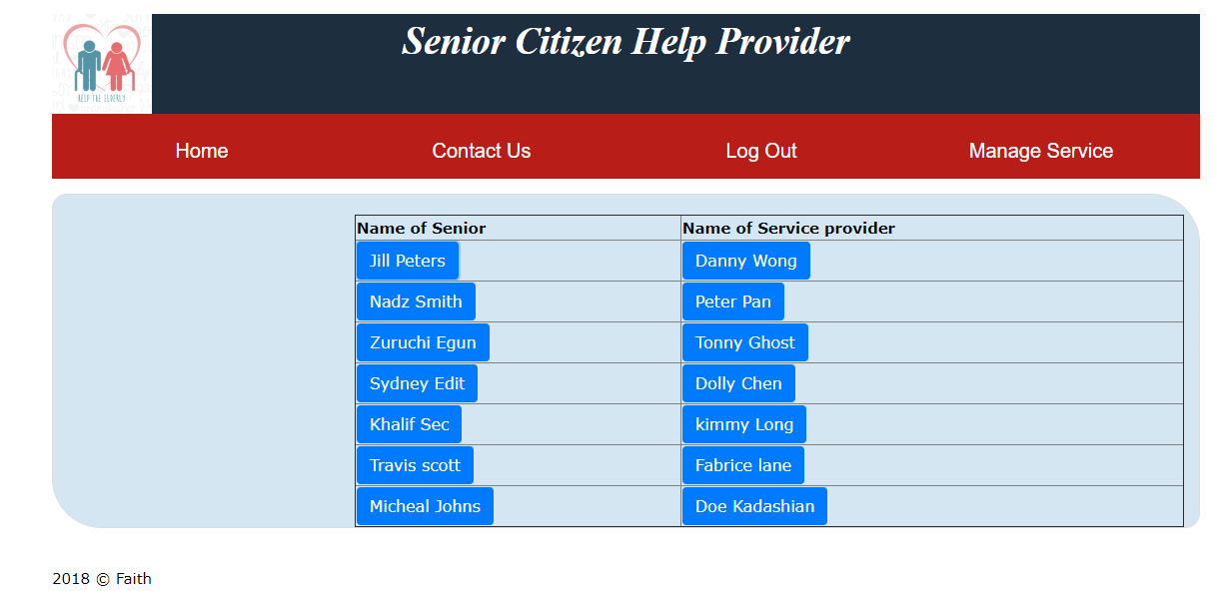

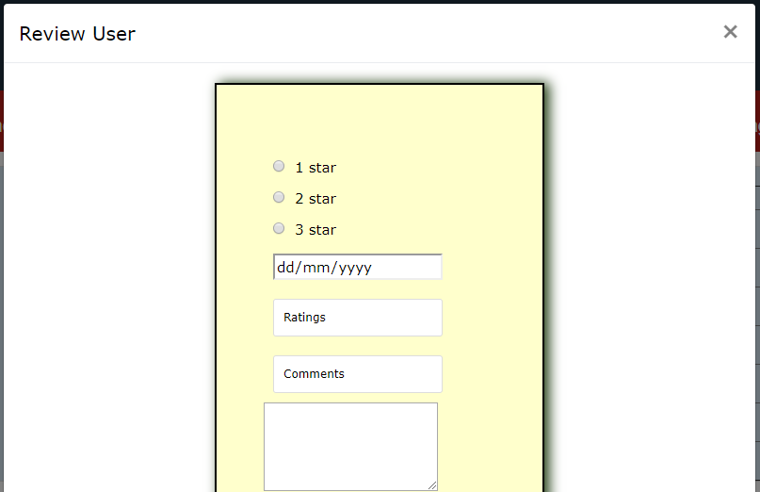

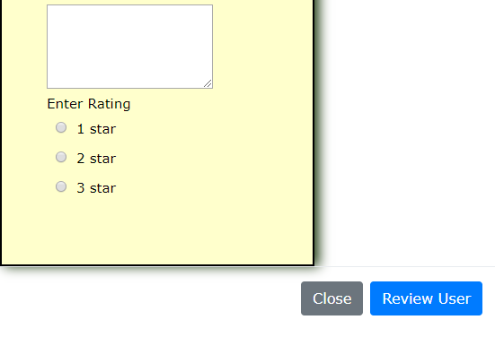

**WEB PAGES AND ITS CODES**

**CSS FILES (For All the Web Pages):**

**Layout:**

body {

margin-left: 100px;

margin-right: 100px;

padding:0;

background-color: #FFFFFF;

color: #000000;

}

#mainB {

background-color: #DfDED4;

}

.carousel-inner{

width:100%;

max-height: 400px !important;

}

#Holder {

width:980;

height:auto;

margin-left: auto;

margin-right: auto;

margin-top: 21px;

margin-bottom: 21px;

}

#Header {

background: url("../image/logo.jpeg");

background-size: contain, cover;

background-repeat: no-repeat;

height:100px;

background-color: #1D2F3E ;

font-size: 250%;

text-transform: capitalize;

font-weight: bold;

font-family:serif;

text-decoration: none;

color: white;

font-style: italic;

text-align: center;

}

#Navbar {

height: 65px;

padding: 10px;

background-color: #B81D18 ;

}

#Navbar nav ul li {

text-align: center;

}

#Content {

height: auto;

clear: both;

overflow: auto;

}

#pageHeading {

padding: 11px;

}

#contentLeft {

align="right"

width: 100px;

float: left;

padding-top: 11px;

padding-left: 11px;

margin-bottom: 20px;

}

#contentRight {

align="right"

width: 100px;

float: right;

padding-right:11px;

padding-top: 11px;

margin-top: 11px;

margin-bottom: 20px;

}

#Footer {

width:auto;

height:auto;

margin-top: 35px;

}

h1 {

margin: 0;

font-family: Arial, Helvetica, sans-serif;

font-weight: lighter;

color: #666;

}

h2 {

margin: 0;

font-family: Arial, Helvetica, sans-serif;

font-weight: lighter;

color: #999;

}

h6 {

margin: 0;

font-family: Arial, Helvetica, sans-serif;

font-weight: lighter;

font-size: 14px;

color: #565;

}

.responsive-video {

max-width:520px;

height: auto;

margin-top: 65px;

border:5px solid #000000;

border-radius: 10px;

}

hr{

height: 20px;

border: 0;

box-shadow: inset 0 12px 12px -12px rgba(256, 0, 0, 0.5);

}

#textAbout {

width: 700px;

float:right;

padding-right:11px;

padding-left:11px;

margin-bottom:100px;

}

body{

font-family:verdana;

font-size:15px;

}

div#back_glob{

background-color: #ffffcc;

border:2px solid #000000;

width:350px;

margin:0px ;

box-shadow:5px 0px 20px #254117;

padding:70px 50px 70px 50px;

}

input{

display: inline;

margin:10px;

}

div#back_header{

background-color:#000000;

text-align:center;

font-size:22px;

font-weight:bold;

color:white;

padding20px;

}

input[type=text], input[type=password],input[type=tel],input[type=number] {

font-size:25px;

padding:10px;

border-radius:3px;

border:1px solid #ddd;

}

input[type=submit] {

background-color:#000000;

padding: 5px 10px 5px 10px;

border-radius:3px;

border:1px solid #dddddd;

color:white;

font-weight:bold;

}

div#back_form {

display:flex;

justify-content: center;

}

.item-card{

margin-top: 4px;

margin-bottom: 4px; margin-left: auto; margin-right: auto;

width: 100%;

background-color: #D4E6F1;

border-radius: 15px 50px;

border:1px solid #ddd;

}

.description{

min-height: 20px;

margin-top: 20px;

}

**Menu:**

nav ul {

margin: 0;

padding: 0;

}

nav ul li {

list-style-type: none;

float: left;

display: block;

width: 280px;

height: 70px;

text-align: center;

line-height: 55px;

font-family: Arial, Helvetica, sans-serif;

font-size: 20px;

}

nav ul li a {

text-decoration: none;

color: #FFFFFF;

}

**Home Page:**

<!DOCTYPE html>

<html>

<head>

<link rel="stylesheet" href="https://stackpath.bootstrapcdn.com/bootstrap/4.1.3/css/bootstrap.min.css" integrity="sha384-MCw98/SFnGE8fJT3GXwEOngsV7Zt27NXFoaoApmYm81iuXoPkFOJwJ8ERdknLPMO" crossorigin="anonymous">

<link href="CSS/Layout.css" rel="stylesheet" type="text/css" >

<link href="CSS/Menu.css" rel="stylesheet" type="text/css" >

<title>Home Page</title>

</head>

<body>

<div id="Holder">

<div id="Header">

<p>Senior Citizen Help Provider</p>

</div>

<DIV id="Navbar">

<nav>

<ul>

<li>

<a href="#">Home</a>

</li>

<li>

<a href="contactUs.html">Contact Us</a>

</li>

<li>

<a href="Login.html">Log In</a>

</li>

</ul>

</nav>

</DIV>

<DIV id="Content"></DIV>

<div class="row">

<div class="col-sm" >

<div id="carouselExampleControls" class="carousel slide" data-ride="carousel">

<div class="carousel-inner">

<div class="carousel-item active">

<img class="d-block w-100" src="https://geriatricnursing.org/wp-content/uploads/2016/02/Psychological-care-of-the-elderly.jpg" alt="First slide">

</div>

<div class="carousel-item">

<img class="d-block w-100" src="http://www.dorotusa.org/images/2012_wrpr/home/slideshow/Donate_2.jpg" alt="Second slide">

</div>

<div class="carousel-item">

<img class="d-block w-100" src="https://www.luxuryww.com/wp-content/uploads/2018/04/181746-saiba-como-escolher-a-melhor-viagem-para-criancas-e-idosos.jpg" alt="Third slide">

</div>

</div>

<a class="carousel-control-prev" href="#carouselExampleControls" role="button" data-slide="prev">

<span class="carousel-control-prev-icon" aria-hidden="true"></span>

<span class="sr-only">Previous</span>

</a>

<a class="carousel-control-next" href="#carouselExampleControls" role="button" data-slide="next">

<span class="carousel-control-next-icon" aria-hidden="true"></span>

<span class="sr-only">Next</span>

</a>

</div>

</div>

</div>

<div id="contentLeft">

<h1>CARING FOR THE ELDERLY : An Overview of Aged Support Systems:</h1>

</div>

<div id="contentRight">

<p>

United Nations published an article on Ageing in the Twenty-First Century (2012), thus defining an ageing populace as an occurrence in which older people become a proportionally larger aspect of the total population because of decline in fertility and increase in life expectancy. Almost every country in the world is experiencing this situation including Malaysia. This circumstance has caused among others the problem of dependency which affect many sectors including the labour and financial market. “Dependency” in this context means individuals who require someone or something for financial or other supports.

In Order to reduce the level of stress for older citizens which require services such as shopping,provision of meal, transportation and health care, we will like to create an information system that can match service providers with seniors who require such service. With the help of the system, these seniors will be able find information and use the services available

</p>

</div>

<br><br>

<DIV id="Footer"> 2018 &copy; Faith</DIV>

</DIV>

<script src="https://code.jquery.com/jquery-3.3.1.slim.min.js" integrity="sha384-q8i/X+965DzO0rT7abK41JStQIAqVgRVzpbzo5smXKp4YfRvH+8abtTE1Pi6jizo" crossorigin="anonymous"></script>

<script src="https://cdnjs.cloudflare.com/ajax/libs/popper.js/1.14.3/umd/popper.min.js" integrity="sha384-ZMP7rVo3mIykV+2+9J3UJ46jBk0WLaUAdn689aCwoqbBJiSnjAK/l8WvCWPIPm49" crossorigin="anonymous"></script>

<script src="https://stackpath.bootstrapcdn.com/bootstrap/4.1.3/js/bootstrap.min.js" integrity="sha384-ChfqqxuZUCnJSK3+MXmPNIyE6ZbWh2IMqE241rYiqJxyMiZ6OW/JmZQ5stwEULTy" crossorigin="anonymous"></script>

</body>

</html>

**Login Page:**

<!DOCTYPE html>

<html>

<head>

<link href="CSS/Layout.css" rel="stylesheet" type="text/css" >

<link href="CSS/Menu.css" rel="stylesheet" type="text/css" >

<title>Login page</title>

<style type="text/css">

body{

font-family:verdana;

font-size:15px;

}

div#back_glob{

background-color: #ffffcc;

border:2px solid #000000;

width:350px;

margin:0px ;

box-shadow:5px 0px 20px #254117;

padding:70px 50px 70px 50px;

}

input{

display: block;

margin:10px;

}

div#back_header{

background-color:#000000;

text-align:center;

font-size:22px;

font-weight:bold;

color:white;

padding:20px;

}

input[type=text], input[type=password] {

font-size:25px;

padding:10px;

border-radius:3px;

border:1px solid #ddd;

}

input[type=submit] {

background-color:#000000;

padding: 5px 10px 5px 10px;

border-radius:3px;

border:1px solid #ddddddLogin;

color:white;

font-weight:bold;

}

div#back_form {

display:flex;

justify-content: center;

}

nav li ul a {

border-radius: 15px;

}

</style>

</head>

<body>

<DIV id="Holder">

<div id="Header">

<p>Senior Citizen Help Provider</p>

</div>

<DIV id="Navbar">

<nav>

<ul>

<li>

<a href="Home.html">Home</a>

</li>

<li>

<a href="contactUs.html">Contact Us</a>

</li>

<li>

<a href="Home.html">Log Out</a>

</li>

</ul>

</nav>

</DIV>

<DIV id="Content"></DIV>

<div class="row">

<div class="col-md-12">

<div id="login_box_container"

style="background: url('https://plus.maths.org/issue45/features/kaplan/Penrose_tiling.gif'); width: 100%; padding: 5px;">

<!--The login box-->

<div id="back_glob" style="margin-left: auto; margin-right: auto;">

<div id="back_header">

Login

</div>

<div id="back_form">

<form action="Home2.html" method="post" >

<input type ="text" name="username" placeholder="userrname" />

<input type ="password" name="password" placeholder="password" />

<input type ="submit" name="valid" value="Login" />

</form>

</div>

<a href="sign_up.html">Sign up</a>

</div>

</div>

</div>

</div>

<DIV id="Footer"> 2018 &copy; Faith</DIV>

</DIV>

</body>

</html>

**Sign up Page**

<!DOCTYPE html>

<html>

<head>

<link href="CSS/Layout.css" rel="stylesheet" type="text/css" >

<link href="CSS/Menu.css" rel="stylesheet" type="text/css" >

<title>Sign Up</title>

</head>

<BODY>

<DIV id="Holder">

<div id="Header">

<p>Senior Citizen Help Provider</p>

</div>

<DIV id="Navbar">

<nav>

<ul>

<li>

<a href="Login.html">Login</a>

</li>

<li>

<a href="contactUs.html">Contact us</a>

</li>

<li>

<a href="Home.html">Logout</a>

</li>

</ul>

</nav>

</DIV>

<DIV id="Content"></DIV>

<div class="row">

<div class="col-md-12">

<div id="login_box_container"

style="background: url('https://plus.maths.org/issue45/features/kaplan/Penrose_tiling.gif'); width: 100%; padding: 5px;">

<div id="back_glob" style="margin-left: auto; margin-right: auto;">

<div id="back_header">

Registration

</div>

<br>

<div id="back_form">

<form action="sign_action.php" method="post">

<div class="form-group">

<input type="radio" name="type" id="sp" value="serviceProvider">

<label for="sp">Service Provider</label>

</div>

<select>

<option value="code1">1234</option>

<option value="code2">abcd</option>

<option value="code2">9876</option>

<option value="code3">zxyw</option>

</select>

<br/><br>

<input id="sn" type="radio" name="type" value="senior">

<label for="sn">Senior</label>

</br>

<input type ="text" name="user_Name" placeholder="userrname" />

<input type ="password" name="pass_Word" placeholder="password" />

<input type ="text" name="fullname" placeholder="Full name" />

<input type ="tel" name="mobile_number" placeholder="Mobile Phone Number" />

<input type ="text" name="address" placeholder="Address" />

<input type ="number" name="service" placeholder="Service code" />

<input type ="submit" name="submit" value="Create" />

</form>

</div>

</div>

</div>

</div>

</div>

<DIV id="Footer"> 2018 &copy; Faith</DIV>

</DIV>

</BODY>

</html>

**Request Service Page**

<!DOCTYPE html>

<html>

<head>

<link rel="stylesheet" href="https://stackpath.bootstrapcdn.com/bootstrap/4.1.3/css/bootstrap.min.css" integrity="sha384-MCw98/SFnGE8fJT3GXwEOngsV7Zt27NXFoaoApmYm81iuXoPkFOJwJ8ERdknLPMO" crossorigin="anonymous">

<link href="CSS/Layout.css" rel="stylesheet" type="text/css" >

<link href="CSS/Menu.css" rel="stylesheet" type="text/css" >

<link href="CSS/slide.css" rel="stylesheet" type="text/css">

<title>Senior Citizen Help Provider</title>

</head>

<body>

<DIV id="Holder">

<div id="Header">

<p>Senior Citizen Help Provider</p>

</div>

<DIV id="Navbar">

<nav>

<ul>

<li>

<a href="Home.html">Home</a>

</li>

<li>

<a href="contactUs.html">Contact Us</a>

</li>

<li>

<a href="serviceRequest.html">Service Request</a>

<select name="codes">

<option value="service1">code123</option>

<option value="service2">code124</option>

<option value="service1">code125</option>

<option value="service2">code126</option>

</select>

</li>

<li>

<a href="submitService.html">Submit Service</a>

</li>

<

</ul>

</nav>

</DIV>

<div>

<div class="row item-card">

<div class="col-sm-3" style="height: 300px; overflow: hidden;">

<img src="https://encrypted-tbn0.gstatic.com/images?q=tbn:ANd9GcS5x4VYQ2SVW5fotLkV1c-DsNrcq90NBvl3AGDHCPNbirYJuX4m" width="100%" height="100%" />

</div>

<div class="col-sm-9 description">

<h1>code123:</h1>

<br><br>

Are you in need of a medical attention? you have come to the right place. with just few clicks, you will be attended to in a short time.

</div>

</div>

<div class="row item-card">

<div class="col-sm-3" style="height: 300px; overflow: hidden;">

<img src="https://media.karousell.com/media/photos/products/2018/01/12/old_people_medical_appointment_transportation_services_1515741439_b3e8b1e90" width="100%" height="100%" />

</div>

<div class="col-sm-9 description">

<h1>code124:</h1>

<br><br>

Book a ride to anywhere you are interested in. within few minutes your driver will arrive. Enjoy free ride as well with promo code.

</div>

</div>

<div class="row item-card">

<div class="col-sm-3" style="height: 300px; overflow: hidden;">

<img src="https://encrypted-tbn0.gstatic.com/images?q=tbn:ANd9GcSpwVL6jXklLJJ8czJGcfOw9NMHhxUS2SDBGNC_u4NoIkB9HJkp9A" width="100%" height="100%" />

</div>

<div class="col-sm-9 description">

<h1>code125:</h1>

<br><br>

Your diet has a lot to do with your health. Request for your favorite dishes and you will be served shortly.

</div>

</div>

<div class="row item-card">

<div class="col-sm-3" style="height: 300px; overflow: hidden;">

<img src="http://bakerfh.com/images/sampledata/House-Cleaning-recommendations.jpg" width="100%" height="100%" />

</div>

<div class="col-sm-9 description">

<h1>code126:</h1>

<br><br>

Dont fret about an unclean environment. request for a helper and be helped.

</div>

</div>

<br>

<DIV id="Footer"> 2018 &copy; Faith</DIV>

</DIV>

<script src="https://code.jquery.com/jquery-3.3.1.slim.min.js" integrity="sha384-q8i/X+965DzO0rT7abK41JStQIAqVgRVzpbzo5smXKp4YfRvH+8abtTE1Pi6jizo" crossorigin="anonymous"></script>

<script src="https://cdnjs.cloudflare.com/ajax/libs/popper.js/1.14.3/umd/popper.min.js" integrity="sha384-ZMP7rVo3mIykV+2+9J3UJ46jBk0WLaUAdn689aCwoqbBJiSnjAK/l8WvCWPIPm49" crossorigin="anonymous"></script>

<script src="https://stackpath.bootstrapcdn.com/bootstrap/4.1.3/js/bootstrap.min.js" integrity="sha384-ChfqqxuZUCnJSK3+MXmPNIyE6ZbWh2IMqE241rYiqJxyMiZ6OW/JmZQ5stwEULTy" crossorigin="anonymous"></script>

</body>

</html>

**Submit Service Request Page**

<!DOCTYPE html>

<html>

<head>

<link href="CSS/Layout.css" rel="stylesheet" type="text/css" >

<link href="CSS/Menu.css" rel="stylesheet" type="text/css" >

<title>Request Service</title>

<style type="text/css">

body{

font-family:verdana;

font-size:15px;

}

div#back_glob{

background-color: #ffffcc;

border:2px solid #000000;

width:350px;

margin:0px ;

box-shadow:5px 0px 20px #254117;

padding:70px 50px 70px 50px;

}

input{

display: block;

margin:10px;

}

div#back_header{

background-color:#000000;

text-align:center;

font-size:22px;

font-weight:bold;

color:white;

padding:20px;

}

input[type=text], input[type=password] {

font-size:25px;

padding:10px;

border-radius:3px;

border:1px solid #ddd;

}

input[type=submit] {

background-color:#000000;

padding: 5px 10px 5px 10px;

border-radius:3px;

border:1px solid #ddddddLogin;

color:white;

font-weight:bold;

}

div#back_form {

display:flex;

justify-content: center;

}

nav li ul a {

border-radius: 15px;

}

</style>

</head>

<body>

<DIV id="Holder">

<div id="Header">

<p>Senior Citizen Help Provider</p>

</div>

<DIV id="Navbar">

<nav>

<ul>

<li>

<a href="serviceRequest.html">Request Service</a>

</li>

<li>

<a href="manageService.html">Manage Service</a>

</li>

<li>

<a href="Home.html">Log Out</a>

</li>

<li>

<a href="ReviewUser.html">Review User</a>

</li>

</ul>

</nav>

</DIV>

<DIV id="Content"></DIV>

<div class="row">

<div class="col-md-12">

<div id="login_box_container"

style="background: url('https://plus.maths.org/issue45/features/kaplan/Penrose_tiling.gif'); width: 100%; padding: 5px;">

<!--The login box-->

<div id="back_glob" style="margin-left: auto; margin-right: auto;">

<div id="back_header">

Submit service request

</div>

<div id="back_form">

<form action="sign_action.php" method="post">

<input type ="number" name="service" placeholder="Service code" />

<input type ="date" name="date" placeholder="" />

<input type ="text" name="fullname" placeholder="enter notes here" />

<input type ="submit" name="submit" value="submit" />

</form>

</div>

</div>

</div>

</div>

</div>

<DIV id="Footer"> 2018 &copy; Faith</DIV>

</DIV>

</body>

</html>

**Accept Service Request Page**

<!DOCTYPE html>

<html>

<head>

<link rel="stylesheet" href="https://stackpath.bootstrapcdn.com/bootstrap/4.1.3/css/bootstrap.min.css" integrity="sha384-MCw98/SFnGE8fJT3GXwEOngsV7Zt27NXFoaoApmYm81iuXoPkFOJwJ8ERdknLPMO" crossorigin="anonymous">

<link href="CSS/Layout.css" rel="stylesheet" type="text/css" >

<link href="CSS/Menu.css" rel="stylesheet" type="text/css" >

<title>Accept Service Request</title>

</head>

<body>

<DIV id="Holder">

<div id="Header">

<p>Senior Citizen Help Provider</p>

</div>

<DIV id="Navbar">

<nav>

<ul>

<li>

<a href="Home.html">Home</a>

</li>

<li>

<a href="contactUs.html">Contact Us</a>

</li>

<li>

<a href="manageService.html">Manage Request</a>

</li>

<li>

<a href="Home.html">Log Out</a>

</li>

</ul>

</nav>

</DIV>

<div>

<div class="row item-card">

<div class="col-sm-3" style="height: 110px; overflow: hidden;">

</div>

<div class="col-sm-9 description">

Service code:123<br>

Request ID:<br>

Date:<br>

Status:<br>

<!-- Button trigger modal -->

<button type="button" class="btn btn-primary view" data-toggle="modal" data-target="#exampleModal">

View Details

</button>

</div>

</div>

<div class="row item-card">

<div class="col-sm-3" style="height: 110px; overflow: hidden;">

</div>

<div class="col-sm-9 description">

Service code:123<br>

Request ID:<br>

Date:<br>

Status:<br>

<!-- Button trigger modal -->

<button type="button" class="btn btn-primary view" data-toggle="modal" data-target="#exampleModal">

View Details

</button>

</div>

</div>

<div class="row item-card">

<div class="col-sm-3" style="height: 110px; overflow: hidden;">

</div>

<div class="col-sm-9 description">

Service code:123<br>

Request ID:<br>

Date:<br>

Status:<br>

<!-- Button trigger modal -->

<button type="button" class="btn btn-primary view" data-toggle="modal" data-target="#exampleModal">

View Details

</button>

</div>

</div>

<div class="row item-card">

<div class="col-sm-3" style="height: 110px; overflow: hidden;">

</div>

<div class="col-sm-9 description">

Service code:123<br>

Request ID:<br>

Date:<br>

Status:<br>

<!-- Button trigger modal -->

<button type="button" class="btn btn-primary view" data-toggle="modal" data-target="#exampleModal">

View Details

</button>

</div>

</div>

<DIV id="Footer"> 2018 &copy; Faith</DIV>

</DIV>

<!-- Modal -->

<div class="modal fade" id="exampleModal" tabindex="-1" role="dialog" aria-labelledby="exampleModalLabel" aria-hidden="true">

<div class="modal-dialog" role="document">

<div class="modal-content">

<div class="modal-header">

<h5 class="modal-title" id="exampleModalLabel">Accept Service Request</h5>

<button type="button" class="close" data-dismiss="modal" aria-label="Close">

<span aria-hidden="true">&times;</span>

</button>

</div>

<div class="modal-body">

RequiredDate <input type ="date" name="date" placeholder="date" /><br>

Notes <input type ="text" name="notes" placeholder="note" style="font-size:12px; padding: 5px; border-radius: 3px;border: 1px solid #ddd";"/><br>

Status <input type ="text" name="status" placeholder="status" style="font-size:12px ; padding: 5px; border-radius: 3px; border: 1px solid #ddd"; />

</div>

<div class="modal-footer">

<button type="button" class="btn btn-secondary" data-dismiss="modal">Cancel</button>

<button type="button" class="btn btn-primary">Accept</button>

</div>

</div>

</div>

</div>

<script src="https://code.jquery.com/jquery-3.3.1.slim.min.js" integrity="sha384-q8i/X+965DzO0rT7abK41JStQIAqVgRVzpbzo5smXKp4YfRvH+8abtTE1Pi6jizo" crossorigin="anonymous"></script>

<script src="https://cdnjs.cloudflare.com/ajax/libs/popper.js/1.14.3/umd/popper.min.js" integrity="sha384-ZMP7rVo3mIykV+2+9J3UJ46jBk0WLaUAdn689aCwoqbBJiSnjAK/l8WvCWPIPm49" crossorigin="anonymous"></script>

<script src="https://stackpath.bootstrapcdn.com/bootstrap/4.1.3/js/bootstrap.min.js" integrity="sha384-ChfqqxuZUCnJSK3+MXmPNIyE6ZbWh2IMqE241rYiqJxyMiZ6OW/JmZQ5stwEULTy" crossorigin="anonymous"></script>

</body>

</html>

**Manage Service Request Page**

<!DOCTYPE html>

<html>

<head>

<link rel="stylesheet" href="https://stackpath.bootstrapcdn.com/bootstrap/4.1.3/css/bootstrap.min.css" integrity="sha384-MCw98/SFnGE8fJT3GXwEOngsV7Zt27NXFoaoApmYm81iuXoPkFOJwJ8ERdknLPMO" crossorigin="anonymous">

<link href="CSS/Layout.css" rel="stylesheet" type="text/css" >

<link href="CSS/Menu.css" rel="stylesheet" type="text/css" >

<link href="CSS/slide.css" rel="stylesheet" type="text/css">

<title>Accept Service Request</title>

</head>

<body>

<DIV id="Holder">

<div id="Header">

<p>Senior Citizen Help Provider</p>

</div>

<DIV id="Navbar">

<nav>

<ul>

<li>

<a href="Home.html">Home</a>

</li>

<li>

<a href="contactUs.html">Contact Us</a>

</li>

<li>

<a href="Home.html">Log Out</a>

</li>

<li>

<a href="ReviewUser.html">Review User</a>

</li>

</ul>

</nav>

</DIV>

<div>

<div class="row item-card">

<div class="col-sm-3" style="height: 110px; overflow: hidden;">

</div>

<div class="col-sm-9 description">

Service Code:123<br>

Service Description:<br>

Request ID:<br>

Required Date:<br>

Status:<br>

<!-- Button trigger modal -->

<button type="button" class="btn btn-primary" data-toggle="modal" data-target="#exampleModal">

View Details

</button>

</div>

</div>

<div class="row item-card">

<div class="col-sm-3" style="height: 110px; overflow: hidden;">

</div>

<div class="col-sm-9 description">

Service Code:123<br>

Service Description:<br>

Request ID:<br>

Required Date:<br>

Status:<br>

<!-- Button trigger modal -->

<button type="button" class="btn btn-primary" data-toggle="modal" data-target="#exampleModal">

View Details

</button>

</div>

</div>

<div class="row item-card">

<div class="col-sm-3" style="height: 110px; overflow: hidden;">

</div>

<div class="col-sm-9 description">

Service Code:123<br>

Service Description:<br>

Request ID:<br>

Required Date:<br>

Status:<br>

<!-- Button trigger modal -->

<button type="button" class="btn btn-primary" data-toggle="modal" data-target="#exampleModal">

View Details

</button>

</div>

</div>

<div class="row item-card">

<div class="col-sm-3" style="height: 110px; overflow: hidden;">

</div>

<div class="col-sm-9 description">

Service Code:123<br>

Service Description:<br>

Request ID:<br>

Required Date:<br>

Status:<br>

<!-- Button trigger modal -->

<button type="button" class="btn btn-primary" data-toggle="modal" data-target="#exampleModal">

View Details

</button>

</div>

</div>

<DIV id="Footer"> 2018 &copy; Faith</DIV>

</DIV>

<!-- Modal -->

<div class="modal fade" id="exampleModal" tabindex="-1" role="dialog" aria-labelledby="exampleModalLabel" aria-hidden="true">

<div class="modal-dialog" role="document">

<div class="modal-content">

<div class="modal-header">

<h5 class="modal-title" id="exampleModalLabel">Manage Service Request</h5>

<button type="button" class="close" data-dismiss="modal" aria-label="Close">

<span aria-hidden="true">&times;</span>

</button>

</div>

<form action="ReviewUser.html" method="post" >

<div class="modal-body">

RequiredDate <input type ="date" name="date" placeholder="date" /><br>

Notes <input type ="text" name="notes" placeholder="note" style="font-size:12px; padding: 5px; border-radius: 3px;border: 1px solid #ddd";"/><br>

Status <br> <input id="com" type="radio" name="com" value="completed">

<label for="com">completed</label>

</br>

<input id="can" type="radio" name="can" value="cancelled">

<label for="can">cancelled</label>

</br>

</div>

<div class="modal-footer">

<button type="button" class="btn btn-secondary" data-dismiss="modal">Close</button>

<button type="submit" class="btn btn-primary">Review User</button>

</div>

</form>

</div>

</div>

</div>

<script src="https://code.jquery.com/jquery-3.3.1.slim.min.js" integrity="sha384-q8i/X+965DzO0rT7abK41JStQIAqVgRVzpbzo5smXKp4YfRvH+8abtTE1Pi6jizo" crossorigin="anonymous"></script>

<script src="https://cdnjs.cloudflare.com/ajax/libs/popper.js/1.14.3/umd/popper.min.js" integrity="sha384-ZMP7rVo3mIykV+2+9J3UJ46jBk0WLaUAdn689aCwoqbBJiSnjAK/l8WvCWPIPm49" crossorigin="anonymous"></script>

<script src="https://stackpath.bootstrapcdn.com/bootstrap/4.1.3/js/bootstrap.min.js" integrity="sha384-ChfqqxuZUCnJSK3+MXmPNIyE6ZbWh2IMqE241rYiqJxyMiZ6OW/JmZQ5stwEULTy" crossorigin="anonymous"></script>

</body>

</html>

**Review User Page**

<!DOCTYPE html>

<html>

<head>

<link rel="stylesheet" href="https://stackpath.bootstrapcdn.com/bootstrap/4.1.3/css/bootstrap.min.css" integrity="sha384-MCw98/SFnGE8fJT3GXwEOngsV7Zt27NXFoaoApmYm81iuXoPkFOJwJ8ERdknLPMO" crossorigin="anonymous">

<link href="CSS/Layout.css" rel="stylesheet" type="text/css" >

<link href="CSS/Menu.css" rel="stylesheet" type="text/css" >

<link href="CSS/slide.css" rel="stylesheet" type="text/css">

<title>Review User</title>

</head>

<body>

<DIV id="Holder">

<div id="Header">

<p>Senior Citizen Help Provider</p>

</div>

<DIV id="Navbar">

<nav>

<ul>

<li>

<a href="Home.html">Home</a>

</li>

<li>

<a href="contactUs.html">Contact Us</a>

</li>

<li>

<a href="Home.html">Log Out</a>

</li>

<li>

<a href="manageService.html">Manage Service</a>

</li>

</ul>

</nav>

</DIV>

<div>

<div class="row item-card">

<div class="col-sm-3" style="height: 110px; overflow: hidden;">

</div>

<div class="col-sm-9 description">

<table border="1" style="width:100%;">

<tr>

<th>Name of Senior</th>

<th>Name of Service provider</th>

</tr>

<tr>

<td ><button type="button" class="btn btn-primary" data-toggle="modal" data-target="#exampleModal">

Jill Peters

</button>

</td>

<td><button type="button" class="btn btn-primary" data-toggle="modal" data-target="#exampleModal">

Danny Wong

</button>

</td>

</tr>

<tr>

<td><button type="button" class="btn btn-primary" data-toggle="modal" data-target="#exampleModal">

Nadz Smith

</button>

</td>

<td><button type="button" class="btn btn-primary" data-toggle="modal" data-target="#exampleModal">

Peter Pan

</button>

</td>

</tr>

<tr>

<td><button type="button" class="btn btn-primary" data-toggle="modal" data-target="#exampleModal">

Zuruchi Egun

</button>

</td>

<td><button type="button" class="btn btn-primary" data-toggle="modal" data-target="#exampleModal">

Tonny Ghost

</button>

</td>

</tr>

<tr>

<td><button type="button" class="btn btn-primary" data-toggle="modal" data-target="#exampleModal">

Sydney Edit

</button>

</td>

<td><button type="button" class="btn btn-primary" data-toggle="modal" data-target="#exampleModal">

Dolly Chen

</button>

</td>

</tr>

<tr>

<td><button type="button" class="btn btn-primary" data-toggle="modal" data-target="#exampleModal">

Khalif Sec

</button>

</td>

<td><button type="button" class="btn btn-primary" data-toggle="modal" data-target="#exampleModal">

kimmy Long

</button>

</td>

</tr>

<tr>

<td><button type="button" class="btn btn-primary" data-toggle="modal" data-target="#exampleModal">

Travis scott

</button>

</td>

<td><button type="button" class="btn btn-primary" data-toggle="modal" data-target="#exampleModal">

Fabrice lane

</button>

</td>

</tr>

<tr>

<td><button type="button" class="btn btn-primary" data-toggle="modal" data-target="#exampleModal">

Micheal Johns

</button>

</td>

<td><button type="button" class="btn btn-primary" data-toggle="modal" data-target="#exampleModal">

Doe Kadashian

</button>

</td>

</tr>

</table>

</div>

</div>

<DIV id="Content"></DIV>

<DIV id="Footer"></DIV>

</DIV>

<!-- Modal -->

<div class="modal fade" id="exampleModal" tabindex="-1" role="dialog" aria-labelledby="exampleModalLabel" aria-hidden="true">

<div class="modal-dialog modal-lg" role="document">

<div class="modal-content">

<div class="modal-header">

<h5 class="modal-title" id="exampleModalLabel">Review User</h5>

<button type="button" class="close" data-dismiss="modal" aria-label="Close">

<span aria-hidden="true">&times;</span>

</button>

</div>

<form action="ReviewUser.html" method="post" >

<div class="modal-body">

<div class="row">

<div class="col-md-12">

<div id="login_box_container"

style="background: ; width: 100%; padding: 5px;">

<div id="back_glob" style="margin-left: auto; margin-right: auto;">

<div id="back_header">

</div>

<form action="Home2.html" method="post" >

<input type ="radio" name="valid" value="1" />1 star<br>

<input type ="radio" name="valid" value="2" />2 star<br>

<input type ="radio" name="valid" value="3" />3 star<br>

<input type ="date" name="valid" value="Date" /><br>

<input type ="text" name="valid" value="Ratings" style="font-size:12px";/><br>

<input type ="text" name="valid" value="Comments" style="font-size:12px";/><br>

<textarea rows="4" cols="18"> </textarea><br>

Enter Rating <br>

<input type ="radio" name="valid" value="1" />1 star<br>

<input type ="radio" name="valid" value="2" />2 star<br>

<input type ="radio" name="valid" value="3" />3 star<br>

</form>

</div>

<div class="modal-footer">

<button type="button" class="btn btn-secondary" data-dismiss="modal">Close</button>

<button type="submit" class="btn btn-primary">Review User</button>

</div>

</form>

</div>

</div>

</div>

<script src="https://code.jquery.com/jquery-3.3.1.slim.min.js" integrity="sha384-q8i/X+965DzO0rT7abK41JStQIAqVgRVzpbzo5smXKp4YfRvH+8abtTE1Pi6jizo" crossorigin="anonymous"></script>

<script src="https://cdnjs.cloudflare.com/ajax/libs/popper.js/1.14.3/umd/popper.min.js" integrity="sha384-ZMP7rVo3mIykV+2+9J3UJ46jBk0WLaUAdn689aCwoqbBJiSnjAK/l8WvCWPIPm49" crossorigin="anonymous"></script>

<script src="https://stackpath.bootstrapcdn.com/bootstrap/4.1.3/js/bootstrap.min.js" integrity="sha384-ChfqqxuZUCnJSK3+MXmPNIyE6ZbWh2IMqE241rYiqJxyMiZ6OW/JmZQ5stwEULTy" crossorigin="anonymous"></script>

</body>

</html>

**Challenges faced during web development**

During the development several challenges where faced with the team. These challenges can be categorized into two main parts which are:

1. **Design of the website:**

The overall design of a website needs to be appealing to the human eye. The team needed to have a design that was both good looking and manageable to be coded in a span of two weeks. The mixer of colors used on the website had to blend seamlessly together so that they apply as one and does not make the site look too exaggerated but more useable. We drew a wireframe that made it a bit earlier to design the website as we followed that, but with time changes were made on the actual website as they did not seem particle as they were on the wireframe.

1. **Website content:**

The type of contents that appears in the website plays an important role in the development. The main reason why people will visit the site is to see what they do and have to offer to the users. We needed to find information that is relevant for both the two users of the website. This was a challenge as one user is an elderly people looking for a service provider while the other is a service provider who wants to provide a service for them. Copyright also played a big roll on the text of contents that is on the website as we would not simply take anything we anything we find regarding the services of the website.

**Web development framework and technologies used in the web development project are:**

1. **Bootstrap:**

Being the most common framework in the word bootstrap was used in the development of the web. It was needed to create a few elements that’s play a big roll on the website. A modal and login form where from partly made from bootstrap. We used this because of the flexibility that it offers.

1. **Java script:**

This is an application framework written in JavaScript. JavaScript follows the mode-view-controller paradigm. It offers several benefits to the website and the developer too. A few of them a standardization, this follows the best industry standards and encourage better coding practices, time waste is reduced as development is faster because prog=duct developers have ready mindset of utilities across typical product development.

**References**

*Pros & Cons of Front-End Frameworks. (2018, April 20). Retrieved from* [*https://envisionitagency.com/blog/2018/04/pros-cons-front-end-web-frameworks/*](https://envisionitagency.com/blog/2018/04/pros-cons-front-end-web-frameworks/)

*Top 10 Front-End Frameworks of 2018. (2018, September 04). Retrieved October 12, 2018, from* [*https://www.keycdn.com/blog/front-end-frameworks*](https://www.keycdn.com/blog/front-end-frameworks)

*Zahringer, D. (2018, June 16). 5 Common Challenges When Building a Website | TM Blog. Retrieved October 5, 2018, from* [*https://www.tmprod.com/blog/2016/5-common-challenges-developing-website/*](https://www.tmprod.com/blog/2016/5-common-challenges-developing-website/)

*(n.d.). Retrieved October 12, 2018, from* [*https://www.w3schools.com/html/html_tables.asp*](https://www.w3schools.com/html/html_tables.asp)

*Otto, M., & Thornton, J. (n.d.). Modal. Retrieved October 12, 2018, from* [*https://getbootstrap.com/docs/4.0/components/modal/*](https://getbootstrap.com/docs/4.0/components/modal/)